**Lyceum of the Philippines University**

Governor's Drive, Manggahan, Gen. Trias City, Cavite

College of Engineering, Computer Studies and Architecture

Laboratory Activity No. 2

**Understanding Input and Output Statements in Turbo C**

Acotin, Cherylle P.

CFPL01E

BSCpE – CpE201

Date the Experiment was Conducted: 09/04/24

Date of Submission: 09/09/24

Paolo Roberto O. Lozada, Meng-CpE

**Instructor**

**Objectives:**

- To understand and implement basic input and output statements in Turbo C.

- To learn how to use `printf` and `scanf` functions for displaying and receiving data.

**Materials Needed:**

- A computer with Turbo C installed.

- A basic understanding of C programming syntax.

**Questions:**

1. **What is the difference between `printf` and `scanf`?**

The difference between 'printf' and'scanf' is that 'printf' is used to output any display, whether it's an instruction or a value from a computation. Whenever you need something to be printed or displayed, 'printf' is the function to use. On the other hand,'scanf' is used to input a value into a specific variable. With'scanf,' you can also identify the data type, such as float, int, or char.

1. **Why is it important to use the correct format specifier (e.g., `%d`, `%s`, `%f`) in `printf` and `scanf`?**

It is crucial to use the correct format specifier to ensure a code's proper execution. Each specifier has a unique function. For instance, '%d' is used for decimal integers, '%f' for floating-point numbers, '%c' for a single character, and '%s' for a sequence of characters. Using them incorrectly will prevent your code from running as intended.

1. **What happens if you input a different data type than expected by the format specifier?**

If you input a different data type to a format specifier, it will result in errors in the code. This can lead to the code not running and will be presented with warnings that there's a wrong input in it. To prevent this, make sure that the format specifier is correct for the following data you want to input into your code.

1. Create a program that asks for a distance in kilometers and converts it into its metric equivalent.

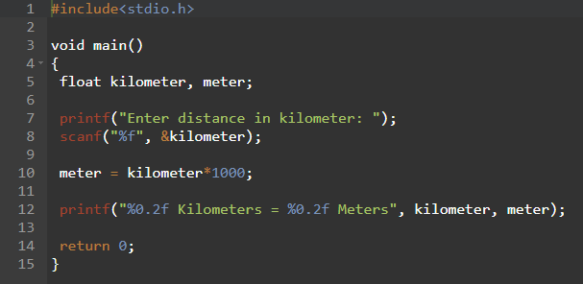

1. Write a program that asks the user to enter the radius of a circle and then computes its area. Recall that the formula to compute for the area is AREA = Pi x R², where R is the radius. The output must be similar to the one below:

The area of the circle with radius 2 cm is 12.56 cm²

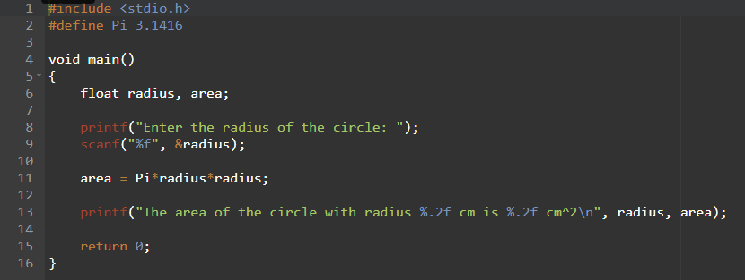

1. Create a program that converts a Fahrenheit measure to a Celsius measure (C = 5/9 * (F - 32)).

1. Write a program that will compute and display the midterm grade of a student. The midterm grade is equal to one-third of the minor A exam and two-thirds of the midterm exam.

1. Create a program that will input a number in kilowatt and display its equivalent measure in watts.

1. Create a program that will compute and display the area of a square. Recall that the formula to compute for the area is AREA = S², where S is the side of the square.

1. Make a program that will convert an inputted number in inches (in) and display its equivalent measure in feet (ft).

1. Create a program that will get as input from the user the base and height of a triangle. Compute and display the area of the rectangle.

1. Write a program that inputs two real numbers then exchanges their values.

1. Make a program that will accept a number in square meters (m²) and display its equivalent measure in hectares (ha). Hint: 1000 m² = 1 ha

